**Experiment name:**

The BJT Biasing Circuits

**Objectives:**

Study of the BJT Biasing Circuits.

**Apparatus:**

* 1x Transistor (C828)
* Resistor - 470Ω , 2.2kΩ, 3.3kΩ, 4.7kΩ, 10kΩ, 470kΩ
* POT - 100kΩ
* Trainer Board
* DC Power Supply
* Digital Multimeter
* Chords and wire

**Theory:**

Biasing a BJT circuit means to provide appropriate direct potentials and currents, using external sources, to establish an operating point or Q-point in the active region. Once the Q-point is established, the time varying excursions of input signal should cause an output signal of same waveform. If the output signal is not a faithful reproduction of the input signal, for example, if it is clipped on one side, the operating point is unsatisfactory and should be relocated on the collector characteristics. Therefore, the main objective of biasing a BJT circuit is to choose the proper Q-point for faithful reproduction of the input signal. There are different types of biasing circuit. However, in the laboratory, we will study only the fixed bias and self-bias circuit. In the fixed bias circuit, shown if figure 6.1, the base current IB is determined by the base resistance RB and it remains constant. The main drawback of this circuit is the instability of Q-point with the variation of β of the transistor. In the laboratory, we will test the stability using two transistors with different β. In the self-bias circuit shown if figure 6.2, this problem is overcome by using the self-biasing resistor RE to the emitter terminal.

**Circuit Diagram:**

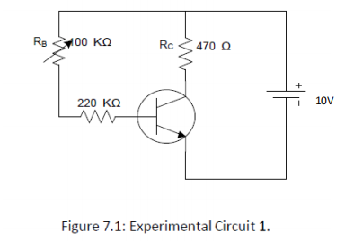 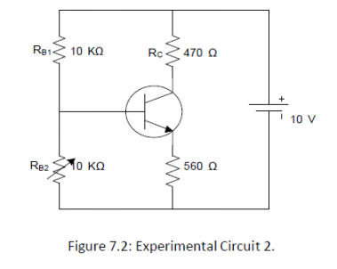

**Experimental Procedure:**

1. At first, we arrange the circuit shown in Figure - 6.1 by C828. Record RC and set RB to maximum value.

2. Then we decrease POT RB gradually so that VCE = VCC / 2 and measure the voltage across RC and VCE.

3. We record the Q-point (VCE, IC).

4. After that, we replace the C828 transistor with BD135 and repeat steps 3 and 4.

5. Then we arrange the circuit shown in Figure - 6.2 by C828. Record RC and set RB to the minimum value.

6. Then we increase POT RB2 gradually so that VCE = VCC / 2 and measure the voltage across RC and VCE.

7. We record the Q-point (VCE, IC).

8. Then we replace the C828 transistor with BD135 and repeat steps 6 and 7.

**Experimental Data Table:**

**Results:**

In this experiment, we built fixed and self-bias circuits and observed how they behave. For the fixed bias circuit, we noticed that the operating points changed significantly when we switched the transistors. Replacing the C282 transistor with BD135 caused the Q-point to shift from (4.703, 10.2) to (6.48, 14.1). This is due to the change in current gain (β) and the temperature. On the other hand, in the self-bias circuit, even after changing the transistor, the operating point remained the same. That is, the current gain (β) and the temperature didn’t affect the self-bias circuit. This indicates that self-bias circuits show better stability compared to fixed-bias circuits.

**Questions and Answers:**

**1. Which circuit shows better stability? Explain in the context of the results obtained in the laboratory.**

**Ans.** The circuit 02 shows better stability.

The first circuit is known as a fixed-biased circuit. The data table of this circuit shows the

instability of the Q-point with the variation of β of the transistor. From the table, we can see that

the Q point is not stable for the experimental circuit-01. However, in the experimental table of circuit 02, known as a self-biased circuit, we can see that the Q point is almost the same. This means the 2nd circuit shows better stability

**2. Draw the DC load line for both the circuits and show the Q-point.**

**Ans.** For the experimental circuit - 01,

VCE = VCC-ICRC

When IC = 0 mA, VCE = VCC - 0 = VCC = 10V

When VCE = 0 V, 0 = VCC - ICRC

IC = = = 21.27 mA

So, connecting the points (10, 0) and (0, 21.27) gives us the load line.

From the data table, for the transistor C828, the Q-point is (4.703, 10.2), and, for the transistor BD135, the Q-point is (6.48, 14.1).

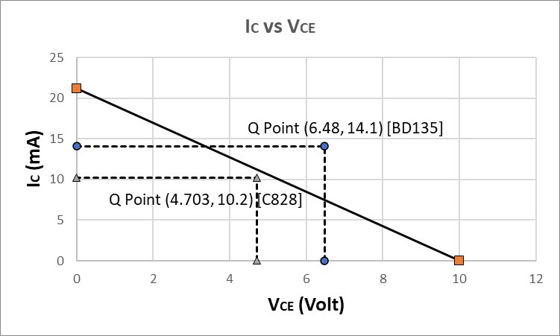

For the experimental circuit - 02,

We know that, VCE = VCC-IC(RC + RE)

When IC = 0 mA, VCE = VCC - 0 = VCC = 10V

When VCE = 0 V, 0 = VCC - IC(RC + RE)

IC = = = 9.7 mA

So, connecting the points (10, 0) and (0, 9.7) gives us the load line.

From the data table, for both the transistors C828 and BD135, the Q-point is (5.05, 7.55).

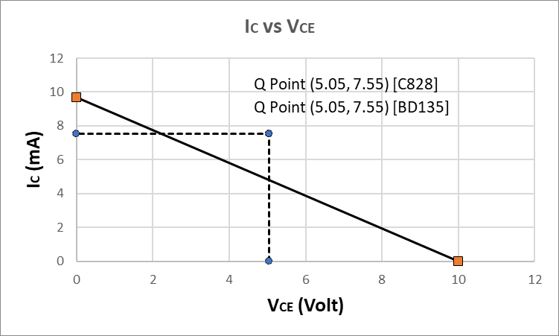

**Discussion:**

From this experiment, we gained practical knowledge about biasing circuits of Bipolar Junction Transistors (BJT), specifically focusing on fixed and self-bias configurations. The experiment demonstrated how these configurations affect the stability of the Q-point and highlighted the importance of emitter resistance in enhancing the circuit's stability. While theoretical calculations provided an initial understanding, the practical implementation revealed slight variations due to component tolerances and differences in transistor β values. These variations emphasized the need to account for real-world factors when designing circuits.

The experiment also highlighted potential sources of error, such as inaccuracies due to component tolerances, measurement errors caused by equipment limitations, and external factors like temperature fluctuations. To minimize these issues, we recommend using components with tighter tolerances, ensuring proper equipment calibration, and conducting experiments in controlled environments. Overall, the experiment was an excellent opportunity to bridge the gap between theory and practice, providing valuable insights into BJT circuit design and improving our understanding of transistor operations in real-world applications.

**Simulation:**

